 | 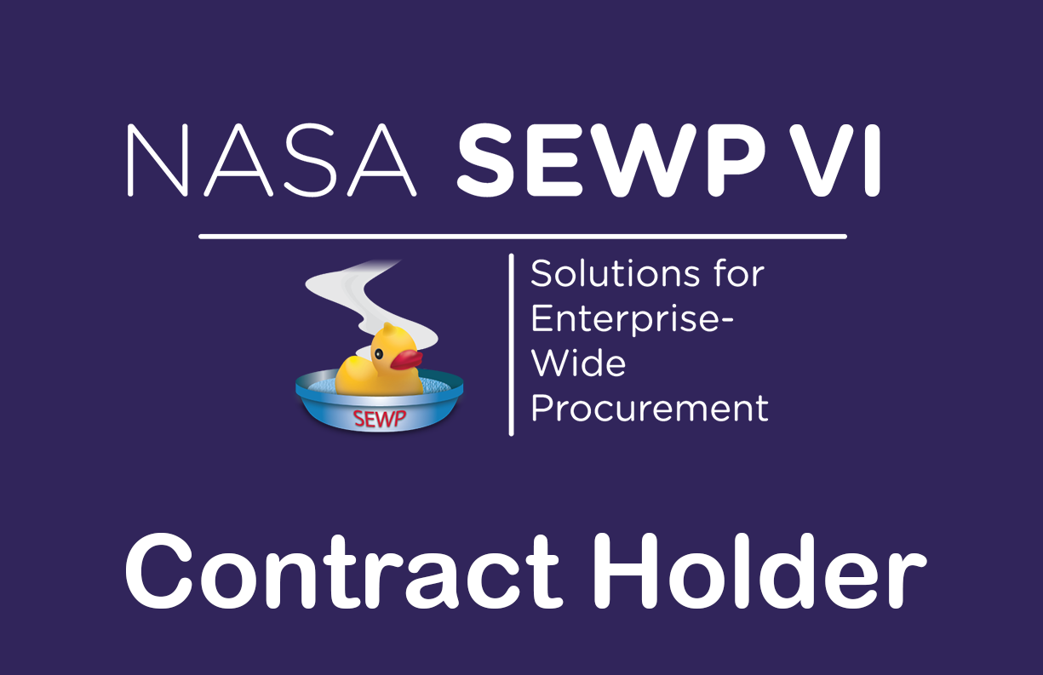
NASA SEWP VI
ORDERING GUIDE
Category C: Mission-Based ITC/AV Service Solutions
Contract Number 80TECH26D0033
CONTRACT HOLDER  Umyuaq Technology, LLC | SEWP VI GO-LIVE  Anticipated November 1, 2026 | GUIDE STATUS  Version 1.2 | September 2026
MISSION FOCUSED. PROVEN RESULTS. TRUSTED PARTNER.
A customer-ready reference for acquiring U-Tech mission-based ITC/AV services through NASA SEWP VI.
This guide explains how to request a quote, satisfy fair opportunity, issue an order, route it through the SEWP Program Management Office, and obtain post-award support.
U-TECH SUPPORT  ContactUs@utech-anc.com | PHONE  (210) 519-5177 | WEB  www.utech-anc.com

1. SEWP VI OVERVIEW AND FAIR OPPORTUNITY
1 | SEWP VI OVERVIEW AND FAIR OPPORTUNITY

What is NASA SEWP VI?
NASA SEWP VI is a Government-Wide Acquisition Contract that provides Information Technology, Communication, and Audio-Visual solutions and services to federal agencies and approved federal contractors. NASA anticipates a November 2026 launch. The contract establishes a 10-year ordering period from its effective date, and qualifying orders may continue for up to 60 months after contract expiration. The SEWP Marketplace and QRT support market research, competition, ordering, and acquisition documentation.

Fair opportunity
FAR 16.505(b)(1) generally requires each contract holder to receive a fair opportunity to be considered for orders exceeding $10,000 under multiple-award contracts, unless an authorized exception applies. The ordering contracting officer selects the acquisition method and documents the rationale for order placement and price. The SEWP QRT is the recommended method because it identifies contract holders within the selected category or source group and supports the acquisition record.
Competition  Select the appropriate SEWP VI category and eligible contract-holder pool. Follow current FAR, agency, and SEWP procedures. | Set-asides  The ordering contracting officer determines whether an order is unrestricted, set aside, or sole source when authorized, and selects the predominant NAICS.
Evaluation  State the technical, management, past performance, price, schedule, and other factors that will govern selection. | Documentation  Maintain the RFQ, responses, evaluation, price determination, fair opportunity rationale, approvals, and award record.

About U-Tech
Umyuaq Technology, LLC (U-Tech) delivers end-to-end mission support across complex federal environments. U-Tech combines technical depth, disciplined program execution, and operational resilience to sustain secure, scalable, and reliable services across medical, training, contingency, infrastructure, and enterprise IT missions.

Administrative handling fee and payment
SEWP fee
An Agency Administrative Handling Fee not to exceed 0.34% applies to SEWP VI orders. U-Tech includes the fee within the total quoted amount. It is not listed as a separate line item on quotes or orders.
SEWP VI contract holders accept payment by electronic funds transfer and Government Purchase Card or other agency-approved credit card. Any authorized purchase-card surcharge must be disclosed in the quote and handled through the applicable SEWP CLIN and contract rules.

2. U-TECH CONTRACT AND PROGRAM SUPPORT
2 | U-TECH CONTRACT AND PROGRAM SUPPORT

Contract information
Contract holder | Umyuaq Technology, LLC (U-Tech)
SEWP VI contract | 80TECH26D0033 | Category C
Award / ordering period | Signed July 6, 2026 | 10 years from the contract effective date (anticipated November 2026-2036)
Maximum / award data | $20,000,000,000 | Award NAICS 541513 | CAGE 7FCZ6
Contract record | 104 Main Street, Suite 201, Dillingham, AK 99576-8700 | (210) 899-1900
Corporate headquarters | 4151 Spruill Avenue, Suite 200, North Charleston, SC 29405-5047
Customer support | (210) 519-5177 | ContactUs@utech-anc.com | www.utech-anc.com

SEWP VI program support
Support area |  | Contact | Email | Phone
Quotes and customer engagement |  | Frank Perry  Business Development Manager | Frank.Perry@WoodRiverFederal.com | (210) 519-5177
Requirements and capture support |  | Daryl Williams, Sr.  Capture Manager | Daryl.Williams@WoodRiverFederal.com | (210) 519-5177
Order and post-delivery support |  | U-Tech SEWP VI Support | ContactUs@utech-anc.com | (210) 519-5177
Executive escalation |  | Will Emerson  President and CEO | will.emerson@utech-anc.com | (210) 519-5223

SEWP Helpline
Customer help: help@sewp.nasa.gov | (301) 286-1478 | Monday through Friday, 7:30 a.m. to 6:00 p.m. Eastern Time | www.sewp.nasa.gov/sewpvi/

Publication control
The U‑Tech SEWP VI Ordering Guide is a controlled document maintained by Umyuaq Technology, LLC (U‑Tech). The SEWP Program Manager is responsible for approving the guide and ensuring its continued accuracy. The Deputy Program Manager is responsible for coordinating revisions, maintaining version control, and publishing approved updates.

The guide will be reviewed whenever U‑Tech’s SEWP VI contract is modified or when its ordering procedures, points of contact, or support processes change. Approved updates will be published electronically within 10 business days following an applicable contract modification.

SEWP Program Manager
Will Emerson
Email: will.emerson@utech-anc.com
Phone: (210) 519-5223

Deputy SEWP Program Manager
Daryl A. Williams, Sr.
Email: daryl.williams@utech-anc.com
Phone: (210) 519-5226

Questions concerning this guide, requests for the current approved version, and recommended corrections should be directed to the SEWP Program Manager or Deputy SEWP Program Manager.

3. WHAT'S IN SCOPE FOR SEWP VI?
3 | WHAT'S IN SCOPE FOR SEWP VI?

SEWP VI provides a broad suite of Information Technology, Communication, and Audio-Visual solutions and services. The contract is organized into three scope categories. For a scope determination, customers may send a requirement overview or bill of materials to help@sewp.nasa.gov.
CATEGORY A  ITC/AV Solutions  Technology products, related services, and integrated ITC/AV solutions. | CATEGORY B  Enterprise-Wide ITC/AV Service Solutions  Broad enterprise service solutions spanning organizations or large operating environments. | CATEGORY C  Mission-Based ITC/AV Service Solutions  Program-level and mission-focused ITC/AV services. U-Tech contract category.

U-Tech Category C solutions
Enterprise IT Operations  Service desk, endpoint support, systems administration, network operations, monitoring, incident response, and service management. |  | Cybersecurity and Compliance  RMF and ATO support, vulnerability management, configuration compliance, eMASS artifacts, POA&M support, and cyber operations.
Network and Systems Engineering  Architecture, design, modernization, integration, testing, deployment, sustainment, and performance optimization. |  | Infrastructure Sustainment  Fiber and copper infrastructure, inside and outside plant support, installation, testing, documentation, and lifecycle maintenance.
Mission and Medical IT  High-availability clinical and mission-system support, secure user services, operational continuity, and specialized technical support. |  | Data, Cloud, and Applications  Database administration, cloud and hybrid services, application support, automation, reporting, collaboration platforms, and digital services.
AV, VTC, and Unified Communications  Conference-room technology, VTC support, voice services, audiovisual operations, event support, and communications integration. |  | Program and Quality Management  Program governance, transition, risk, staffing, quality control, metrics, deliverables, knowledge transfer, and continuous improvement.

Category C scope controls and order thresholds
Category C supports mission/program-level ITC/AV services; product-only requirements are not in scope. Services may be performed worldwide at Government or contractor locations as specified in each order. Orders are limited to $2 million, including options, during Year 1 and $10 million, including options, during Year 2. NASA may remove the restrictions beginning in Year 3.

4. ORDERING PROCESS: OBTAIN A QUOTE
4 | ORDERING PROCESS: OBTAIN A QUOTE

Use the SEWP Quote Request Tool
The QRT is the primary and recommended method for seeking market information and competitive quotes. It supports fair opportunity, routes requests to the selected contract-holder pool, provides controlled Q&A, and preserves the acquisition record.
1 | Build the request: Include the SOW or PWS, required outcomes, labor categories or skill requirements, deliverables, place of performance, security, period of performance, evaluation factors, response instructions, and due date.
2 | Select the competition: Choose Category C and the appropriate contract-holder group, socioeconomic pool, suggested source, or other authorized fair-opportunity approach.
3 | Issue through the QRT: Publish the request and use the QRT Q&A feature for clarifications while the request is open unless the customer expressly authorizes direct communication.
4 | Receive U-Tech response: U-Tech submits its response through CHOP on U-Tech letterhead, states the quote validity period, and provides the required verification file with on-contract CLINs.
5 | Evaluate and select: Apply the stated evaluation method, document the selection and price decision, and issue the agency delivery order.

SEWP request types
Type | Purpose | Key point
RFQ | Specific acquisition requirement | Generally supports award. Quoted CLINs must be on contract and a verification file is required.
RFI | General information gathering | CLINs do not have to be on contract at the time of response and a verification file is not required. Any not-yet-available item must be clearly identified, and U-Tech must submit the applicable technology refreshment request.
MRR | Market research for a defined need | CLINs must be on contract at the time of response and a verification file is required.
RFS | Storefront or BPA request | All CLINs must be on contract and the response must include a verification file.

U-Tech response controls: Partial quotes are submitted only when the request expressly permits them; otherwise U-Tech provides a no-bid if it cannot meet the full requirement. During an open QRT request, communications use the Q&A feature unless the customer expressly authorizes another method.

What U-Tech needs from the customer
• Statement of objectives, SOW, PWS, bill of materials, or other written requirements, including mission outcomes and the technical environment
• Sites, dependencies, security, access constraints, labor, qualifications, clearances, certifications, service levels, and surge coverage
• Period of performance, transition window, milestones, deliverables, acceptance, invoicing, and Government POCs
• Evaluation factors, submission format, page limits, pricing instructions, response due date, and award schedule
Sensitive or classified requirements: Do not place classified, PII, CUI, or other restricted information in SEWP tools unless authorized. Use the secure method directed by the agency and coordinate minimum processing data with the PMO.

5. ORDERING PROCESS: PLACE THE ORDER
5 | ORDERING PROCESS: PLACE THE ORDER

Agency order workflow
1 | Issue the agency order: Issue a valid delivery order with a unique agency order number. Cite U-Tech contract 80TECH26D0033 and include the required order data.
2 | Submit the order to the SEWP PMO: The customer should submit the order or modification to sewporders@sewp.nasa.gov or fax (301) 286-0317. If U-Tech receives it directly, current CHUM procedures permit U-Tech to forward it and require U-Tech to ensure timely processing.
3 | SEWP validates the order: The PMO checks the order and CLIN verification data. Totals or CLIN mismatches must be corrected before processing.
4 | SEWP assigns the SCN: The PMO assigns the SEWP Control Number. U-Tech does not begin fulfillment before assignment.
5 | U-Tech acknowledges and performs: After processing, U-Tech marks the order received in CHOP within one business day, coordinates kickoff or delivery, and reports status changes within two business days.

Required order information
✓ Order date and unique agency order number  ✓ Authorized ordering official name, phone, and email  ✓ Issuing agency and ordering agency, if different  ✓ U-Tech legal name and contract number 80TECH26D0033  ✓ Appropriation and accounting data | ✓ Billing, invoicing, and shipping or performance address  ✓ SEWP CLINs, descriptions, unit prices, and quantities  ✓ Total order amount matching the verification file  ✓ SOW/PWS, terms, security, deliverables, and acceptance  ✓ Service period of performance and option instructions

Order modifications
Route every modification through the SEWP PMO. U-Tech must provide a new verification file covering the original order and all modifications to date. Changes to scope, funding, options, CLINs, pricing, delivery, or performance terms must be documented and remain within SEWP VI scope.
Critical control
Do not direct U-Tech to begin work, ship, or otherwise fulfill the order before the SEWP PMO assigns the SCN. A contracting officer notice of intent or unsigned funding document is not a substitute for a processed order.

Submission addresses
SEWP ORDER SUBMISSION  sewporders@sewp.nasa.gov | SEWP ORDER FAX  (301) 286-0317 | U-TECH ORDER SUPPORT  ContactUs@utech-anc.com  (210) 519-5177

6. POST-AWARD AND SUPPORT
6 | POST-AWARD AND SUPPORT Warranty, software, and issue resolution

Post-award operating rhythm
Order acknowledgement  U-Tech marks the processed order received in CHOP within one business day, confirms the order package, assigns accountable leadership, and identifies dependencies requiring customer action. | Kickoff and transition  For service orders, U-Tech aligns governance, staffing, access, deliverables, risks, security, site readiness, and performance baselines.
Status and reporting  U-Tech updates CHOP within two business days of an order-status change, submits monthly progress reports for active orders, and submits the final order report within 30 days after completion. | Acceptance and invoicing  U-Tech supports inspection, acceptance, and closeout; submits invoices to the order's designated billing/payment office; and sends required monthly invoice copies for Category C orders to the SEWP PMO.

Installation, warranty, and software support
Installation and deployment | For deliverable items, standard delivery is within 30 calendar days after PMO processing unless an expedited or non-standard schedule is mutually agreed in the quote or order. Site prerequisites, integration, testing, acceptance, documentation, and knowledge transfer are order-specific.
Basic warranty | U-Tech provides the applicable commercial warranty and the contract-required protections for merchantability and fitness for the order's stated purpose. Service correction and acceptance terms are governed by the quote and order.
Extended warranty and maintenance | Extended warranty or monthly maintenance may be ordered during the standard commercial warranty period using approved SEWP CLINs; the ordered coverage period and response terms control.
Software and subscriptions | Software maintenance, licensing, subscriptions, support, entitlement, hosting, data rights, and Government EULA terms must be represented by the appropriate SEWP CLINs and stated in the quote and order.
Returns and RMA support | Provide U-Tech Order Support the SCN, agency order number, CLIN, serial number, acceptance date, problem, and requested remedy. Items returned before Government acceptance are not subject to restocking fees or other charges unless the return results from a Government-initiated change.

Troubleshoot a problematic order
1 | Contact U-Tech Order Support: Provide the SCN, agency order number, affected line item or service, location, impact, dates, supporting evidence, and desired outcome.
2 | Confirm ownership and action plan: U-Tech assigns an owner, validates priority, coordinates providers or delivery teams, and communicates next actions and target dates.
3 | Escalate if needed: Escalate unresolved technical, schedule, invoice, warranty, or performance issues to Frank Perry and then to Will Emerson for executive resolution.
4 | Engage the SEWP PMO: For contract procedure, order processing, scope, or unresolved SEWP concerns, contact help@sewp.nasa.gov or (301) 286-1478.

7. CONTACTS, RESOURCES, AND REVISION CONTROL
7 | CONTACTS, RESOURCES, AND REVISION CONTROL

U-Tech corporate information
Legal name | Umyuaq Technology, LLC (U-Tech)
SEWP VI contract | 80TECH26D0033 | Category C
Contract record address | 104 Main Street, Suite 201, Dillingham, AK 99576-8700 | (210) 899-1900
Corporate headquarters | 4151 Spruill Avenue, Suite 200, North Charleston, SC 29405-5047
Customer support | (210) 519-5177 | ContactUs@utech-anc.com
Website | www.utech-anc.com
Identifiers | UEI J3JQPCE9H887 | CAGE 7FCZ6 | Award NAICS 541513

NASA SEWP customer resources
SEWP website: https://www.sewp.nasa.gov/sewpvi/
Program information, marketplace access, tools, training, scope, and customer resources.
SEWP customer help: help@sewp.nasa.gov | (301) 286-1478
Customer questions, scope assistance, and acquisition support. Hours shown by NASA: Monday through Friday, 7:30 a.m. to 6:00 p.m. Eastern Time.
Order submission: sewporders@sewp.nasa.gov | Fax (301) 286-0317
Submit delivery orders and order modifications to the SEWP PMO.
Contract Holder help: chhelp@sewp.nasa.gov | (301) 286-4555
Contract-holder procedures, policy, order questions, and CHOP support.

Revision history
Version | Date | Change | Owner
1.0 | September 2026 | Initial Category C ordering guide prepared from NASA SEWP VI onboarding materials and U-Tech corporate information. | U-Tech
Next | Within 10 business days of applicable modification | Update contract, contacts, ordering procedures, or support terms as required. | SEWP PM

Authoritative source references
U-Tech executed SF 1449 award, signed July 6, 2026, and 80TECH26DXXXX SEWP VI Terms and Conditions (contract-specific award and controlling clauses).
NASA SEWP VI Contract Holder User Manual, Version 2, August 21, 2026: SEWP VI CHUM
NASA Example Ordering Guide for SEWP VI Contract Holders: Example Ordering Guide
NASA SEWP VI onboarding page and current program updates: SEWP VI Home
Important notice
This guide summarizes customer procedures and does not replace the executed SEWP VI contract, applicable FAR provisions, agency policy, the current SEWP website, or the ordering contracting officer's judgment. If guidance conflicts, the executed contract and current NASA SEWP instructions control. Before external publication, confirm U-Tech's designated SEWP Program Manager and Deputy Program Manager, verify the contract number and effective date in CHOP or the latest contract modification, and review any subsequent NASA guidance.

